First you need to create a new repository in Github. This can be done using the Github main page. You can give whatever name you want to the repository. Make sure to change the project to Public in order for everyone to see it. If you want the project to be accessed just by you, you can leave it on private mode:

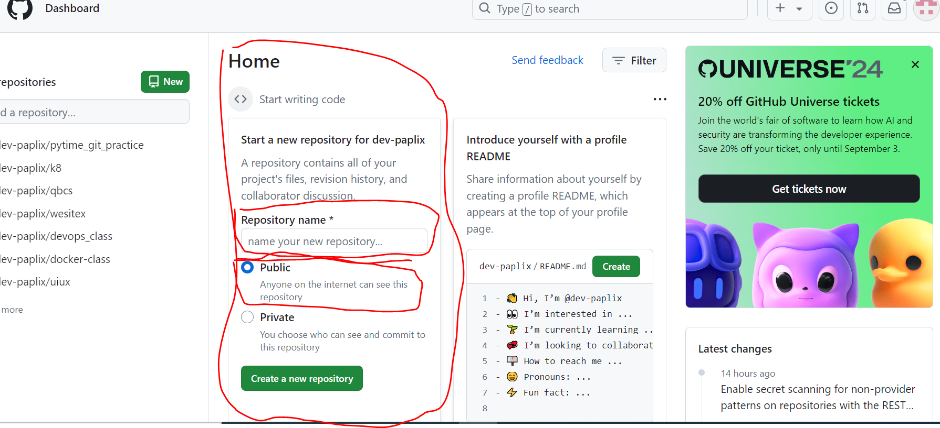

After creating a project, a few lines appear which we are going to need later on:

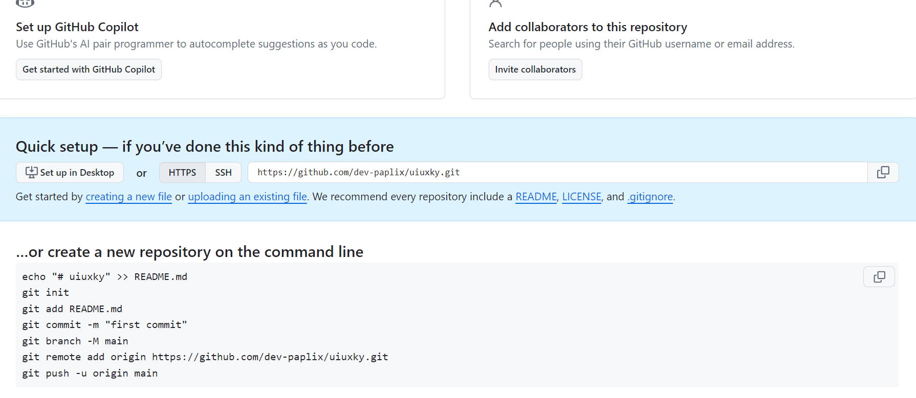

Now lets go the project folder in our windows and copy the directory. You can do that by copying the location in the top bar of the folder:

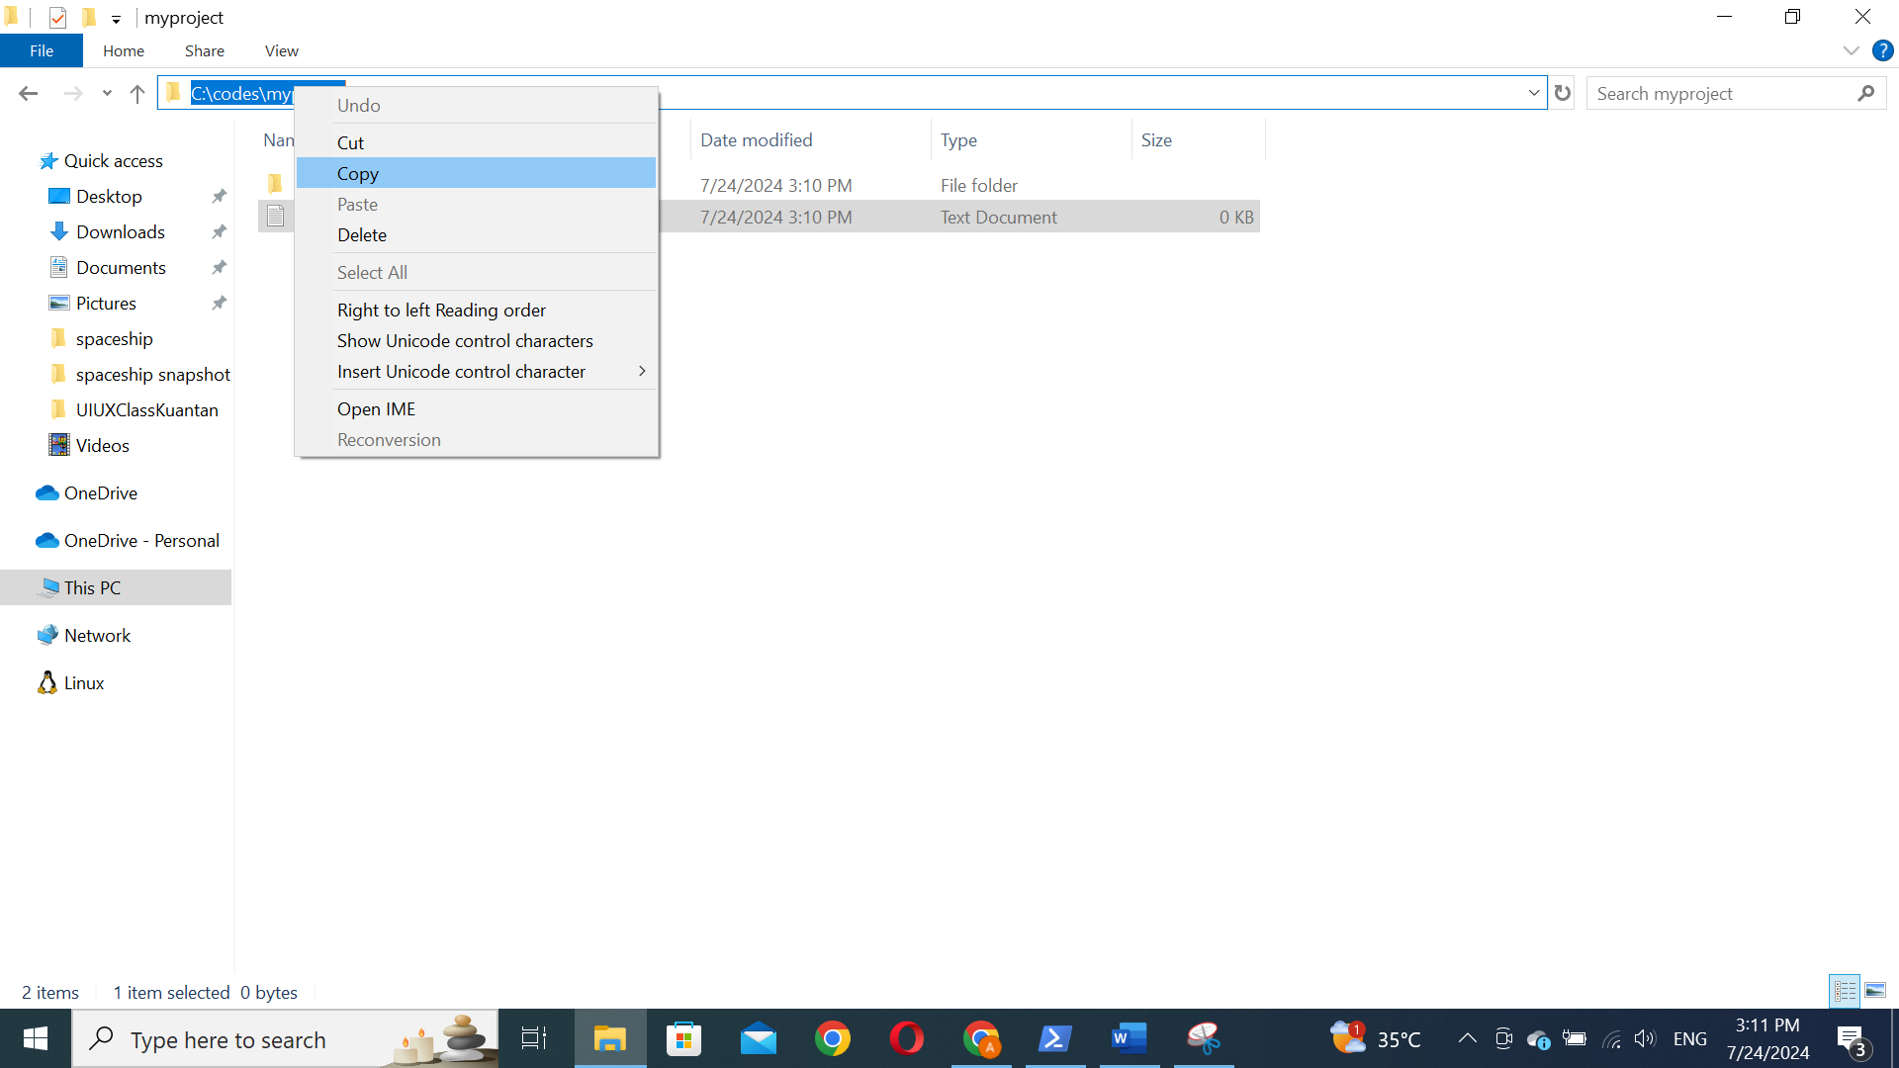

Now lets go back to the power shell and use the copied folder location to use it for our repo. For that purpose you need to use the following command:

cd folder location

for example for me is:

cd C:\codes\myproject



Now you need to initialize the git in your folder, to do that, you need to use the following command:  
git init

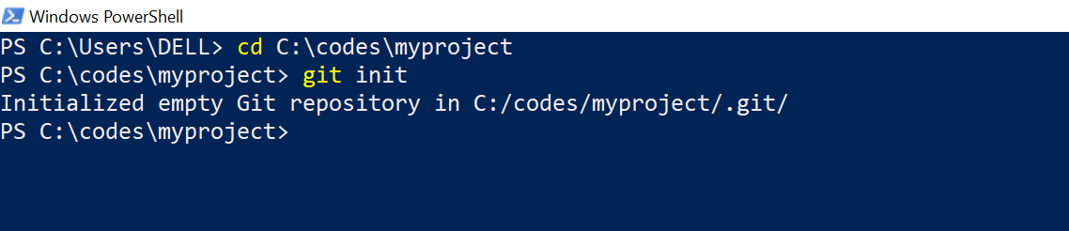

You will receive a message that shows it is successfully initialized.

Now it is to connect to the remote Github repository using the following line:

git remote add origin link

for example for me is, this link can be found from the same page shows immediately after creating repository:

git remote add origin <https://github.com/dev-paplix/uiuxky.git>

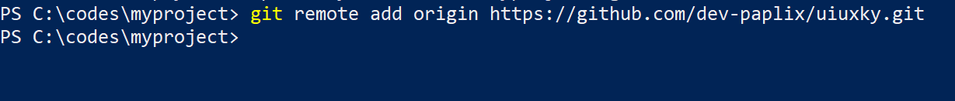

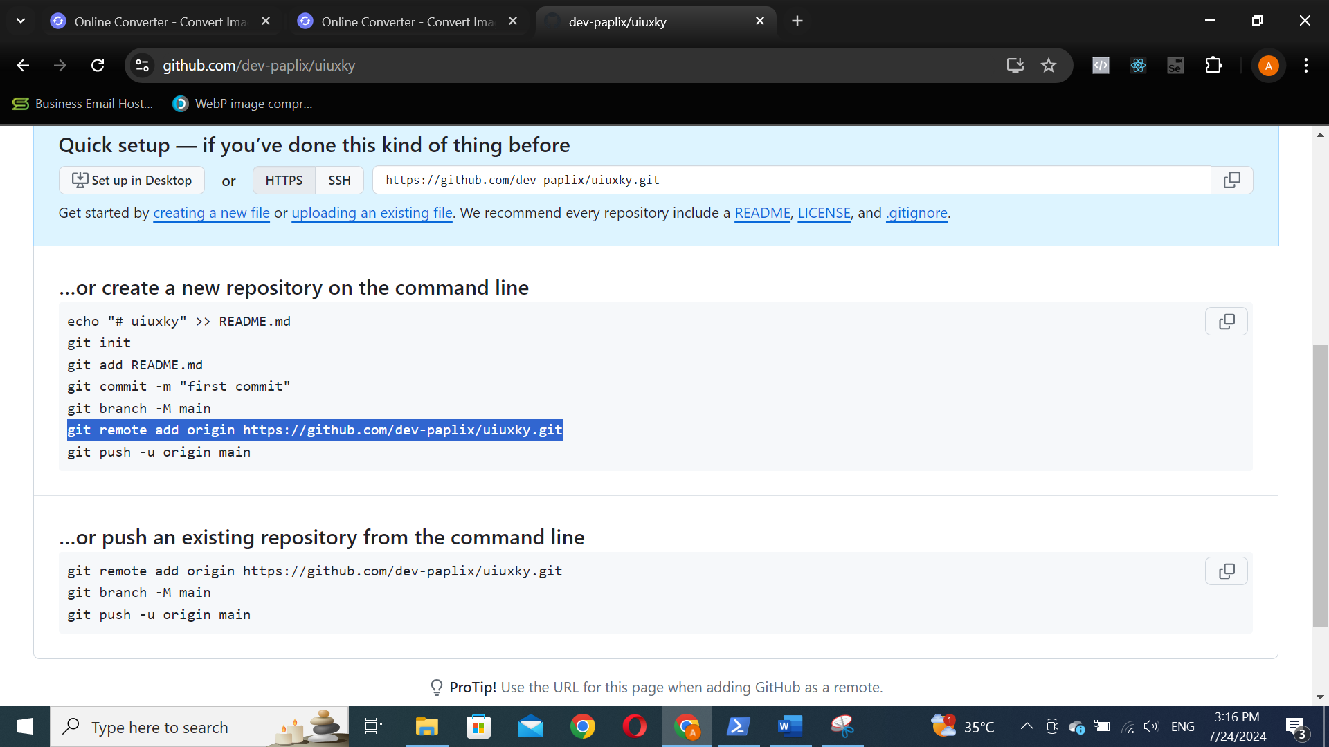

Now you need to specify the branch by running the command:

git branch -M main

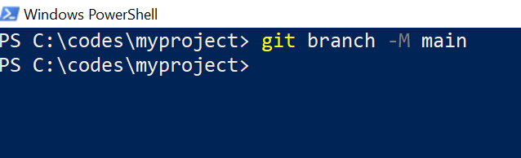

The you have to add all the contents in your folder to the repository by using the following command:

git add .

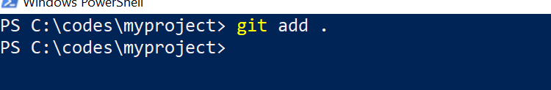

Now its a time to commit your changes using the following command:  
git commit -m “Insert whatever you want ”

For example for me is

git commit -m “initial commit”

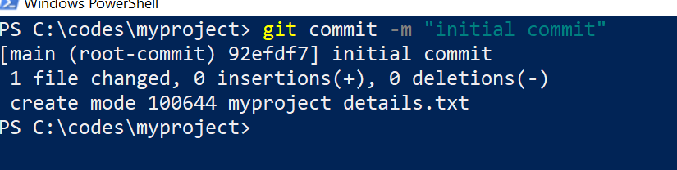

Finally you need to push the entire thing to the remote repository by using the following command:

git push -u origin main

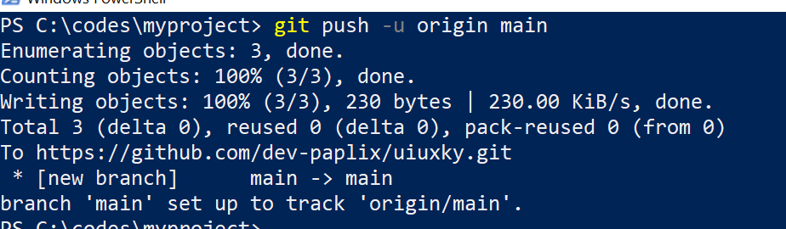

Now if you refresh your github page you can see the files and folders in your remote repository:

